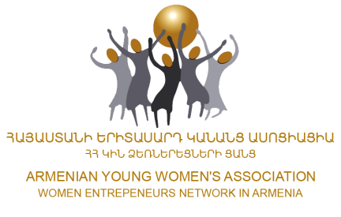

**NEW JOB**

Armenian Young Women’s Association-AYWA is looking for an ICT Expert for development of the multilingual web platform, for the project BSB-541 TEAWAY.

This ICT tool will be a joint achievement of the partnership and the different modules (which will be defined on the way of the project implementation as the particular training courses will provide the input for the definition of the modules) will be designated to each project partner.

**Main duties and responsibilities:**  
As ICT Expert of the project he/she should;

* Track, compile, and analyze web site usage data.
* Develop or document style guidelines for web site content.
* Identify, standardize, and communicate levels of access and security.
* Inform web site users of problems, problem resolutions or application changes and updates.
* Provide training or technical assistance in web site implementation or use.
* Review or update web page content or links in a timely manner, using appropriate tools.
* Monitor web developments through continuing education, reading, or participation in professional conferences, workshops, or groups.
* Collaborate with web developers to create and operate internal and external web sites, or to manage projects, such as e-marketing campaigns.
* Develop and implement marketing plans for home pages, including print advertising or advertisement rotation.
* Create articles, posts, share information with general public.

**Representation**

* Participate in ongoing formal and informal meetings with staff, counterparts;
* Actively get engaged in publicizing AYWA activities, providing general information regarding AYWA and the Projects' purpose and how those interested might participate, as well as promoting understanding of program accomplishments.

**Profile of candidate**

* Excellent writing skills
* Language skills in English, Russian and Armenian
* Critical thinking
* Knowledge of website development, new technologies
* Diploma in Engineering, Science or Journalism and PR is a plus.